Sprint 3 - Agility Design Document

December 04, 2023

**Table of Contents**

1. Executive Summary 3

1.1 Project Overview 3

1.2 Purpose and Scope of this Specification 3

2. Product/Service Description 3

2.1 Product Context 3

2.2 User Characteristics 3

2.3 Assumptions 3

2.4 Constraints 3

2.5 Dependencies 3

3. Requirements 3

3.1 Functional Requirements 3

3.2 Security 4

3.2.1 Protection 4

3.2.2 Authorization and Authentication 4

3.3 Portability 4

4. Requirements Confirmation/Stakeholder sign-off 4

5. System Design 4

5.1 Algorithm 4

5.2 System Flow 5

5.3 Software 5

5.4 Hardware 5

5.5 Test Plan 5

5.6 Task List/Gantt Chart 6

5.7 Staffing Plan 6

# Executive Summary

## Project Overview

The product is designed to navigate around an obstacle course and hit pins at the end of the course, the teacher is the intended audience.

## Purpose and Scope of this Specification

* The intended audience was chosen because that is who is grading this project

# Product/Service Description

Factors that affect the product is the surface that the robot is placed on. If it is a rough or unbalanced surface the robot won’t be able to perform the obstacle course correctly. If the battery is low then the robot won’t properly perform the course.

## Product Context

This product is related to other products created by the same company Sphero. It is not independent because in order for the robot to be programmed to move, the Sphero Edu application must be downloaded.

## User Characteristics

* Faculty / Student
* No experience required
* Small amount of technical experience

## Assumptions

There is a computer with the Sphero Edu application downloaded on a computer with bluetooth on it. The person operating the computer must have some understanding on how to boot up and run the program.

## Constraints

* Different software being used to run the code
* Old or damaged models of the robot
* Computer that doesn’t have bluetooth

## Dependencies

* The project must be used on a Mac to show the sensor data
* The floor must be a flat area so that the robot runs properly
* The robot must be on and connected using bluetooth to the Mac computer

# Requirements

* The robot should zigzag across the bottles, avoiding them. (Prio 1)
* It should speed up and jump over the binder. (Prio 1)
* It should then move straight and hit the pins (Prio 1)
* It would be nice to make the robot straighter and hit more pins (Prio 2)

## Functional Requirements

| **Req#** | **Requirement** | **Comments** | **Priority** | **Date Rvwd** | **SME Reviewed / Approved** |
| --- | --- | --- | --- | --- | --- |
| AGIL_01 | Zigzag around a bottle | Has to avoid three separate bottles | 1 | 12/01 | 12/02 |
| AGIL_02 | Jump over a ramp | Increase speed to make sure it jumps the ramp | 1 | 12/01 | 12/02 |
| AGIL_03 | Move forward and hit the pins | Increase the speed to make it move straighter | 1 | 10/01 | 12/02 |
|  |  |  |  |  |  |
|  |  |  |  |  |  |
|  |  |  |  |  |  |
|  |  |  |  |  |  |
|  |  |  |  |  |  |
|  |  |  |  |  |  |

## Security

### Protection

* One person's computer will have the program so no one can access it except the owner of that computer

### Authorization and Authentication

In order to make sure no unauthorized people get access to the program, only the members of the group and professor will be able to see the code.

## Portability

* The Sphero has host-dependent code and it is the only component;
* All written code is dependent on usage of the Sphero;
* The computer must have the Sphero Edu IDE
* The environment around must be a flat surface or else the robot won’t move correctly

# Requirements Confirmation/Stakeholder sign-off

|  |  |  |
| --- | --- | --- |
| **Meeting Date** | **Attendees (name and role)** | **Comments** |
| 12/04/23 | Justin: programmer, Garrett: problem solver/tester | Set up and tested most of the code |
| 12/04/23 | Justin: Programmer | Finished up the code and recorded the video |

# System Design

## Algorithm

* The ball will move forward until it passes the first bottle
* It will zigzag in the other direction to pass another bottle and again for the third bottle
* It will move right and increase speed to make it over the ramp
* It will then move back and increase speed to hit the pins

## System Flow

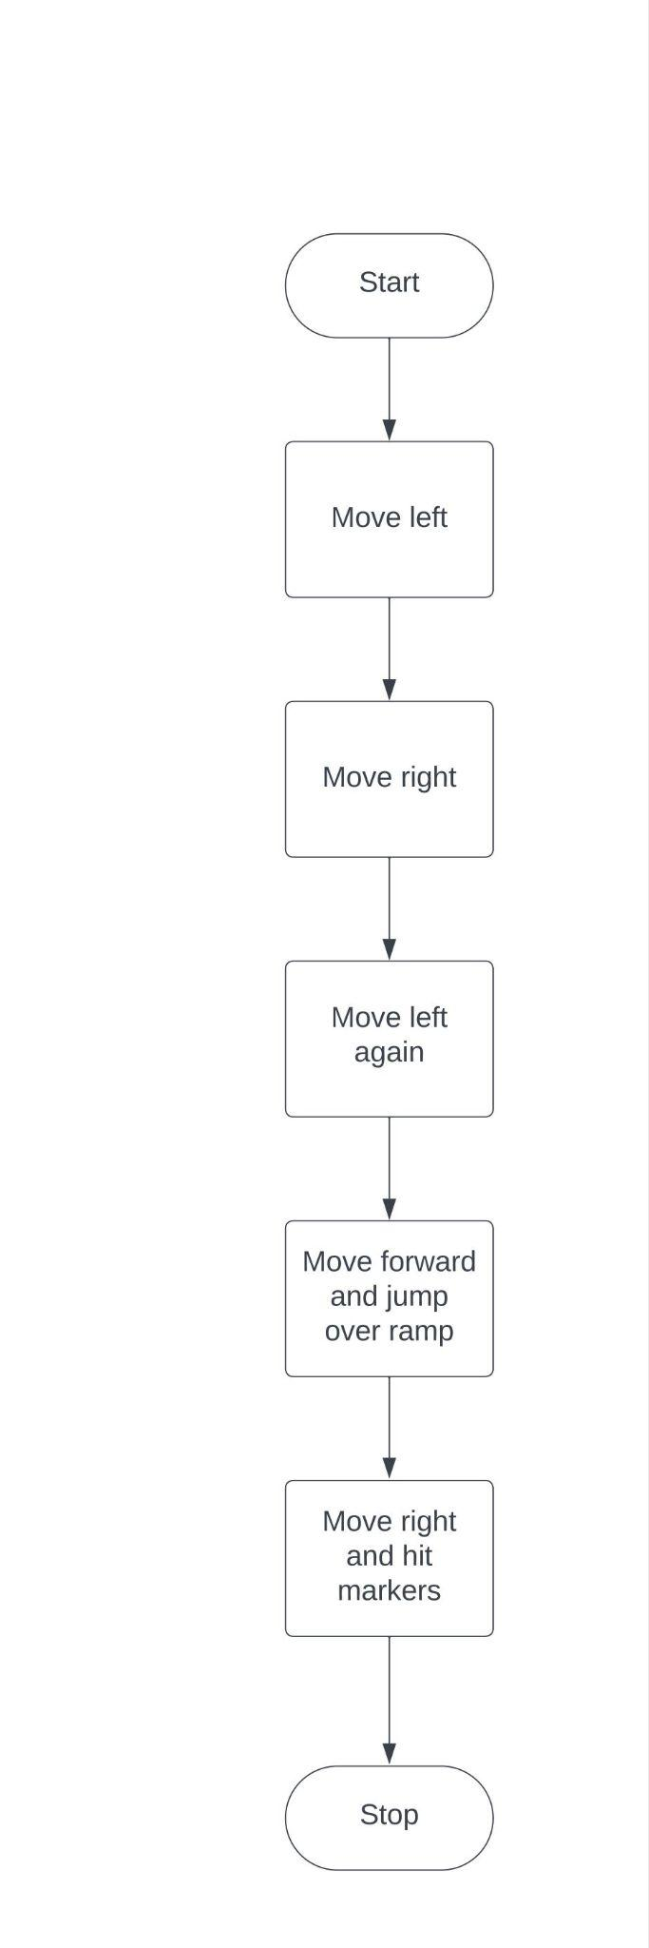

## Software

We used block code as our language on the API, Sphero edu.

## Hardware

We used Mac and windows laptops

## Test Plan

| **Reason for Test Case** | **Test Date** | **Expected Output** | **Observed Output** | **Staff Name** | **Pass/Fail** |
| --- | --- | --- | --- | --- | --- |
| work out time and speed of first straight away/turn | 12/4/23 | To go too far | slightly too far | Garrett  Justin | Fail |
| Fix the amount of time | 12/4/23 | to stop at right length and turn | stopped at the right time | Garrett  Justin | Pass |
| Adjust path so ball avoids the bottles and stops before the straight away that leads to the jump | 12/4/23 | to make it to the straight away before the ramp without hitting a bottle | Hit bottles, went off course, didn’t end at the right place | Garrett  Justin | Fail |
| Adjust path so ball avoids the bottles and stops before the straight away that leads to the jump | 12/4/23 | to make it to the straight away before the ramp without hitting a bottle | didn’t hit any bottles and arrived at the desired point. | Justin  Garrett | Pass |
| Test jump | 12/4/23 | Go over jump and land on the line facing the final obstacle | didn't get over the jump | Garrett  Justin | Fail |
| Upped speed to see if it got over ramp | 12/4/23 | Get over ramp and land in desired location | made it over ramp, went too far | Garrett  Justin | Fail |
| Try to get ball to land in desired location | 12/4/23 | Get over ramp and land in desired location | landed in desired location | Garrett  Justin | Pass |
| testing final objective of bowling | 12/4/23 | Have ball hit the markers at the end of the course | hit the markers | Garrett  Justin | Pass |
| Final test of whole course | 12/4/23 | Have the ball complete the whole course without hitting a bottle, making it over the ramp, not going off course, and hitting the markers at the end | It completed the course cleanly | Garrett  Justin | Pass |
|  |  |  |  |  |  |
|  |  |  |  |  |  |

## Task List/Gantt Chart

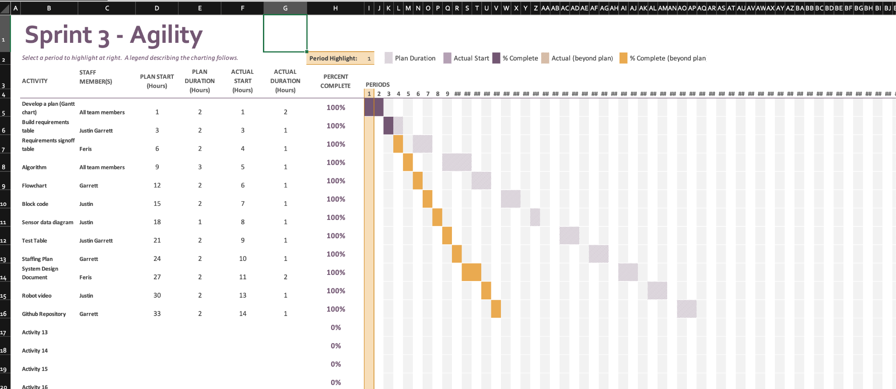

## Staffing Plan

| Name | Role | Responsibility | Reports To |
| --- | --- | --- | --- |
| Justin Veltri | Programmer | Creates algorithm for robot | Justin |
| Garrett Boag | Tester | Tested robot algorithm | Fares/Justin |
| Fares | SDD documentor | Wrote SDD | Fares |

